**This document serves as a short introduction to the National and European policy and regulations on energy relevant for the Clean Energy for EU islands initiative. The text can be copied directly into the Clean Energy Transition Agenda or used as a starting point to write a more island specific National and European policy and regulations section.**

**State: April 2020.**

## Policy and Regulation

### Local policy and regulation

Description of the local policy and specific regulation on the island

### Regional policy and regulation

Description of the regional policy and specific regulation on the region

### National policy and regulation

Choose the relevant national policy summary for your island

1. Croatia

Croatia has around 4.28 million inhabitants and is rich in potential for renewable energy, mainly wind, hydro and solar1. In 2016 the country produced 52.2% of its total primary energy supply, From the imported energy - 47.8% - in 2016, 76.9% consisted of fossil fuel2 but there has been a substantial increase in renewable energy in the latest years3. Croatia joined the European Union (EU) in 2013, and the energy sector has been undergoing liberalization, deregulation, and unbundling of state-owned energy utilities4. Energy efficiency for final consumers, improved by an average of 1.3% per year from 2000 to 2015, or by 19% over the same period. In the industry sector, energy efficiency improved by 28%, or on average by 1.9% per year from 2000. In the transport sector, energy efficiency improved by 10%, or on average by 0.7% per year. In the residential sector, there is also visible a significant progress in energy efficiency. It improved by 21% over the period from 2000 to 2015, or on average by 1.4% per year. This trend can be explained by the introduction of various regulations and financial incentives (grants and subsidies) affecting buildings and appliances5.

1. Targets

Croatia has set the following targets **for 2030** in its final National Energy and Climate Plan (NECP)6:

* Reduction of at least 43% in greenhouse gas emissions for the ETS sector, compared to 2005;
* Reduction at least 7% in greenhouse gas emissions for non-ETS sectors, compared to 2005;
* 36.4% share of Renewable Energy Sources in gross final energy consumption;
* 13.2% share of Renewable Energy Sources in final energy consumption in transport.

In its final NECP, particular attention is put on Islands as several measures proposed in the plan specifically address the islands and the specific needs that the islands have in terms of electricity generation, energy efficiency and decarbonisation.

In May 2019, the Croatian Government proposed a new national Energy Strategy to run until 2030, **including a perspective to 2050**. The proposal is still under review but envisages three scenarios7. Should Croatia proceed gradually with the implementation of what the EU has set out in the energy sector (the second scenario), then by 2030 wind energy is expected to account for 21.3% of power generation, solar energy 6.1%, geothermal energy 0.8%, while hydroelectricity will see its share drop at 44% from 62% in 20107.

1. Sector regulation

* The Croatian Energy Regulatory Agency (HERA) is an autonomous, independent and non-profit public institution which regulates energy activities in the Republic of Croatia8.
* The Croatian Energy Market Operator (HROTE) performs tasks necessary for the functioning of energy markets in the Republic of Croatia and monitors relationships between market participants9.
* The Croatian Electricity Transmission and Distribution Operator (HEP Group) was the national electricity company engaged in electricity production, transmission and distribution, but is now after unbundling divided in HOPS d.o.o6 the Croatian transmission system operator and HEP-Operator d.o.o. (HEP-DSO) as the Croatian distribution system operator10.
* The Croatian implementing agency for energy efficiency programmes (HEP ESCO) provides services in energy project development and focuses specifically on energy efficiency projects11.
* The Environmental Protection and Energy Efficiency Fund (FZOEU) is one of the Croatian institutions managing all tenders and money transfers regarding energy efficiency and renewable energy projects12.

1. Energy communities

Both Renewable Energy Communities (REC) and prosumers concepts are recognized under the Croatian law for some time already. They are regulated by a set of legislations, with the Renewable Energy Act13 being the centrepiece[1]. Although there is no legal definition of a REC, guidance is provided in a policy document of the Ministry of Environmental Protection and Energy “Expert Basis for Preparation of the Croatian Low Carbon Strategy for Period until 2030 with a Look onto 2050” (the White Book) from May 201714. Based on this White Book and other regulations these are the most important features for a REC:

* A cooperative regulated by the Croatian Cooperatives Act, would be the preferred legal form;
* A REC is entitled to produce, consume, store and sell electricity, according to the rules applicable to prosumers;
* A supply licence is required for selling electricity to end-users, therefore, peer-to-peer trading without a license is not allowed;
* Renewable energy projects located in the same building or multiapartment block can be developed, owned and operated by a REC, however it would not be possible to share produced energy with its members, if they do not obtain a supplier license and sign a supplier agreement between themselves as supplier and consumers.

In the Croatian NECP is mentioned that an action plan will be developed for the development of energy and renewable energy communities and related regulation.

1. Ireland

Ireland has excellent renewable energy resources. The primary sources are wood, water, wind, wave and some wastes. Others include tidal power, solar power (thermal and PV), biomass and biofuels15. Ireland’s overall energy system remains heavily reliant on fossil fuels but the country is making strong efforts in the wind-energy sector. From the imported energy in 2016, 98.4% consisted of fossil fuel2. In 2017, about a quarter of the country’s total power generation came from wind power16. Ireland’s electricity system is capable of accommodating up to 65% of instantaneous variable generation at any given time17. Energy efficiency for final consumers improved by an average of 2.3% per year from 2000 to 2015 or 29% over the period. Energy intensity in Industry reduced dramatically, due to structural changes in the economy in the early 2000's, with a move away from energy intensive industries to low energy intensity, high value added sectors. Residential energy intensity reduced significantly after 2006, due to a combination of improvements to building efficiency and economic factors18.

1. Targets

Ireland is committed to a substantial low-carbon transformation of its economy and energy sector. The 2015 White Paper “Ireland’s Transition to a Low Carbon Energy Future 2015-2030” sets out a framework for energy policy to 2030 and sets out a vision for a profound transformation of Ireland’s energy systems19:

* moving to lower emissions fuels and ultimately towards a lower reliance on fossil fuels;
* significantly increasing renewable generation;
* achieving a step-change in energy efficiency performance;
* implementing smart and interconnected energy systems;
* strong regulatory structures and markets to underpin these changes;
* repositioning energy consumers to have a more active role within the energy sector.

The draft[2] National Energy and Climate Plan (NECP)20 sets out details on a year-by-year basis up to 2030, while also looking out to 2035 and 2040.

At the end of 2019 the Irish Government made several announcements with measures to achieve its targets in the - still to be submitted - final NECP:

* A new Renewable Electricity Support Scheme (RESS) to increase the share of renewable energy capacity to 70% by 2030, will see four (possibly five) auctions held between 2020 and 2027;
* In heating and cooling, heat pumps will feature prominently;
* Considerable growth in the scheme for renewable heat and biogas is foreseen;
* Transport will see a greater focus on electric mobility;
* A ramping up of the energy efficiency programmes is foreseen.

In July 2019, the Irish Government recently its Climate Action Plan to meet these goals and to lay the foundations for achieving net zero carbon emissions by 2050. The Plan sets out 180 actions that need to be taken and extends to all sectors of the economy21.

1. Sector regulation

* The Department of Communications, Climate Action and Environment oversees the formulation and implementation of policies concerning Ireland's coal, gas, peat, oil, electricity and renewable energy supply22.
* The Sustainable Energy Authority of Ireland (SEAI) was established as Ireland's national energy authority under the Sustainable Energy Act 200223. SEAI's mission is to play a leading role in transforming Ireland into a society based on sustainable energy structures, technologies and practices.
* The Commission for Regulation of Utilities (CRU) is Ireland’s independent energy and water regulator24.
* As the Transmission System Operator (TSO) EirGrid plc ensures the safe, secure and economic operation of the high voltage electricity grid25. ESB Networks is the licensed electricity distribution network operator and owner26.

1. Energy communities

The *Sustainable Energy Communities program* is managed by the SEAI and is underpinned by the energy white paper27, which aims to engage and enable energy citizens. This document sets out government actions to achieve a low carbon energy system by 2050 and become carbon-free by 2100. Within the white paper, specific commitments are made to support community involvement in renewable energy projects.

The SEC program provides:

* Technical support such as energy management skills training and knowledge sharing;
* Financial support such as dedicated funding.

1. Greece

Greece has access to renewable energy sources such as hydro-power, wind, solar energy and biomass. Almost 61% of Greece’s primary energy needs are fulfilled through imports, mainly fossil fuel -99.6% -, with the remaining 39% being covered through domestic energy sources, mainly lignite (77%) andRenewable Energy Sources(22%)28. Greece is making strong efforts as it nearly doubled its share from RES, from 6.9% of gross final energy consumption in 2004, to 15.5% in 201729. Over the period 2000 to 2015 the energy efficiency for final consumers improved by 33%. The larger decrease was registered to transport sector with a decrease of 40% over the period, then to industry with a decrease of 29% and to household with a decrease of 28%30.

1. Targets

The government’s declared policy is to diversify energy sources and reduce the carbon dioxide (CO2) intensity of the economy while increasing energy security and implementing energy market reforms to make the sector more competitive31.

Greece’s final National Energy and Climate Plan (NECP)32 contains the following targets:

* In terms of renewable energy, the target for 2030 is set at a share of 35%. To achieve this goal;
* Increasing energy savings with one-third of current consumption by 2030;
* The reduction of energy poverty, by ensuring equal and unhindered access to basic goods and services for all;
* Decrease of greenhouse gas (GHG) emissions in the non-ETS sector by 16% compared to 2005.

The final NECP contains among others the following measures to achieve those targets:

* A radical transformation of the electricity sector, as renewable energy will substitute fossil fuels with over 60%-64% of final electricity consumption;
* Putting an end to the energy isolation of the islands by early 2029 at the latest and to have them interconnected with the mainland system, thus eliminating the utility services costs, as well as to have innovative hybrid Renewable Energy Sources power generation systems set up on those islands that will not be interconnected or will be interconnected later on, for the benefit of all consumers:
  + In the period 2020-2030, almost all the Aegean islands will also be interconnected, starting with the interconnection of Crete;
  + For islands that are not expected to be interconnected, a significant reduction in the use of diesel for power generation is also being promoted, with the setup of state-of-the-art Renewable Energy Sources plants combined with storage technologies.
* Creation of a sustainable development model in all sectors of the economy;
* Development of the energy sector in accordance with environmental protection;
* formation of energy policy by weighting the cost-benefit ratio with energy transition; waste management and circular economy;
* Creating a Greek energy hub that will contribute to EU’s energy security;
* Creation of an appealing investment environment which will support and promote energy transition;
* Maximum utilization of state resources;
* Extroversion and creation of jobs;
* Reduction of dependence on lignite power.

1. Sector regulation

* The Ministry of Environment and Energy (YPEN) has the responsibility for the definition and implementation of the national energy policy as well as the coordination of the energy sector, including the promotion of RES33.
* The Regulatory Authority for Energy (RAE) is an independent administrative authority, with financial and administrative independence under the supervision of YPEN.
* RAE monitors the operation of the energy markets, including electricity from RES34.
* The Operator of the Electricity Market (LAGIE) has the responsibility for the operation of the electricity market35.
* The Independent Power Transmission Operator S.A. is the Transmission System Operator for the Hellenic Electricity Transmission System36.
* The Hellenic Electricity Distribution Network Operator S.A. (HEDNO/DEDDIE) is tasked with the operation, maintenance and development of the power distribution network in Greece37.
* The Centre forRenewable Energy Sourcesand Saving (CRES) is a national entity for the promotion of RES, rational use of energy and energy conservation38.

1. Energy communities

The Greek law on *Energiaki Kinotita*, or Energy Community (EC) was adopted in January 2018 (Law 4513/2018), introducing a new type of civil cooperative in Greek company law and the wider framework of Social and Solidarity Economy (Law 4430/2016). This new legal vehicle enables citizens, local governments and small to medium size companies to set up urban for-profit and not-for-profit cooperatives, active exclusively in the field of energy, locally and regionally. According to this law, energy communities should be performing at least one of the following activities:

* Generation, storage, self-consumption, sale of electricity or heating/cooling from Renewable Energy Sources within the district of its seat;
* Management of raw material for production of electricity or heating/cooling from biomass, bio-waste, or biofuel;
* Procurement, for its members, of appliances and installations with increased energy efficiency as well as electric vehicles, vehicles using natural gas, biofuel or liquefied gas;
* Distribution of electricity or supply of electricity and natural gas within the district of the seat.

By law these energy communities are non-profit organizations, however, they are entitled to share profit if they have at least 15 members, or in case of islands with population below 3.100 inhabitants, 50% of which are individuals. They are also entitled to certain financial incentives regulated by this new law. Additional support will be regulated by the Ministry of Environment and Energy or RAE.

1. Spain

The Spanish energy sector is well developed however, the country imported 71.9% of its energy in 2016, of which 99.2% was from fossil fuels2. In 2018, over 40 % of total generation was obtained using renewable energy technologies39. Spain is one of the frontrunners for renewable energy deployment with 25,7 GW of total installed wind capacity. In 2019 Spain was Europe’s leading market for onshore wind. Energy efficiency displays continuous progress throughout the 2000-2015 period at an average annual rate of 1.5% (cumulatively 22.5%). The contributions of transport and industry stand out owing to their greater share of demand, and they displayed average annual rates of improvement of 0.9 and 1.7%. The residential and transport sectors have carried on apace and at a faster rate, 3.8 and 1.3%40.

1. Targets

In 2018 Spain has set out the ambition to switch its electricity system entirely to renewable sources by 2050 and completely decarbonise its economy soon after. In its final National Energy and Climate Plan (NECP)41 it provides measures that should allow the following results to be achieved in 2030:

* 23 % reduction in greenhouse gas (GHG) emissions compared to 1990. Spain intends to reach this target by, among others, better integrating renewables into the grid, developing self-consumption and distributed generation and supporting biofuels in transport.
* 42 % of energy end-use from renewables. This is based on measures that ensure visibility and stability in the medium term, greater flexibility and greater participation of citizens in the energy system, as well as specific support measures in those areas where necessary.
* 39.6 % improvement in energy efficiency. To this end measures for more efficient use of means of transport, for upgrading the vehicle fleet and promoting electric vehicles and measures for energy efficiency in existing buildings in the residential sector are proposed
* 74 % renewable energy in electricity generation. To achieve this, Spain intends to invest massively in wind (annual installation of 2,2 GW up to 2030) and solar power over the next decade, while banning new licences for fossil fuel drilling and fracking wells.

In 2050 the objective is to achieve climate neutrality, with the reduction of GHG emissions by at least 90 %, in line with the European Communication, as well as achieving a 100 % renewable electricity system.

Spain places an **important role in the Autonomous Communities** as it states in its final NECP that the increase of the renewable generation capacity envisaged will only be viable with the active involvement and full collaboration of the Autonomous Communities42.

1. Sector regulation

* The Ministry for the Ecological Transition (MITECO) is the department of the Government of Spain responsible for developing the government policy on amongst others energy, with under its organisation the Secretariat for Energy43.
* Also assigned to the MITECO is the Institute for the Diversification and Saving of Energy (IDAE) which aims at improving the country’s energy efficiency and increase the use of renewable energy and other low carbon cost technologies44.
* The National Markets and Competition Commission, is among others, responsible for the regulatory supervision bodies of the energy45.
* OMI-Polo Español S.A. (OMIE) is the market regulator46.
* Red Eléctrica de España (REE) is the company dedicated to the transmission of electricity and the operation of the transmission electrical system (the national grid)47.
* There are 5 distribution system operators in Spain: Endesa, Iberdrola, Naturgy, EDP España and Viesgo.

1. Energy communities

Certain rules for self-consumption were already in place in Spain based on Royal Decree-Law 15/201848. The Royal Decree 244/1949 in place since the 5th of April 2019 regulates the administrative, technical and economic details, thus completing the existing framework.

The new Decree:

* enables collective self-consumption by groups of apartment owners or in industrial estates;
* reduces administrative procedures, especially in the case of small self-consumers;
* establishes a simplified mechanism for compensation of energy fed into the public grid.

As such there is no legal concept of an energy community, but where self-consumption previously was only allowed with generation facilities located in the same dwelling, the new decree allows power surpluses to be shared with nearby consumers also in other buildings or fed to the grid. For this, the generation facilities should be connected to the internal network of associated consumers – by direct lines for instance - or to the low voltage network derived from the same center of transformation.

1. Italy

Italy has the advantage of receiving ample sunlight because of its geographical location, therefore, the solar photovoltaic sector is emerging as one of the dominant renewable energies. However, Italy relies on import, 77.5%, of which 91.0% is fossil fuel, to meet its energy requirements2. To reduce that dependence on others, Italy has started tapping its renewable resources in the last decade50. In 2017, the most important renewable energy source (RES) was Hydropower, which contributed to about 14% of the country’s gross electricity production51. Energy efficiency for final consumers improved by 14% over the period 2000-2015, with an average rate of 1% per year from 2000 to 2015. In industry the energy efficiency improvement has been steady and significant: 1.7% per year over the period 2000-2015. The progress in transport sector has been constant (1% per year). The residential sector had a steady progress at 0.7% per year over the period 2000-201552.

1. Targets

In its final National Energy and Climate Plan (NECP)53, Italy has created a strategy that will allow the country to contribute to the achievement of the goals set by the Energy Union:

* Italy aims at 30% of gross final consumption to be covered by renewable sources by 2030 by promoting the gradual phasing out of coal for electricity generation in favour of an electricity mix based on a growing share of renewables and, for the remainder, gas;
* Regarding energy efficiency, the goal is set at a reduction in primary energy consumption of 43% and final energy of 39.7% compared to what was reported in the PRIMES 2007 energy plan. Italy will focus on policies for reducing demand for mobility and increasing collective mobility, in particular rail transport. Italy will mainly integrate the energy efficiency aspect into policies and measures whose main purpose is something other than efficiency, in order to optimise the cost-benefit ratio of the actions, for example in the building sector as part of earthquake proofing;
* Italy’s 2030 target for greenhouse gas (GHG) emissions in the non-ETS sector, is -33% compared to 2005. To achieve this Italy intends to gradually phase out coal for electricity generation. Italy envisages a central role for solar in the nation’s energy mix, with PV expected to represent more than half the power generation capacity - 50 GW - from renewables by 2030.

In its final NECP Italy stated that it will promote the creation of systems, starting with a few small islands disconnected from the national networks, in which an accelerated decarbonisation process and electrification of consumption with renewable sources can be trialled. In this context, the Ministerial Decree of 14 July 201754 sets out specific targets for covering consumption with renewable energy sources, available locally for each island. It establishes specific incentives, the scope of which is defined by ARERA Decision No 558 of 6 November 2018 and is proportionate to the avoided fuel cost.

The aim is to promote, for each island:

* The modernisation of electricity networks to allow more renewables;
* the implementation of pilot projects designed to increase the use of renewables by using storage systems, developing electric transport, integrating the electricity system with the island water systems and with the scalable demand on the island. A public call for projects is being finalised and will allow experimentation with innovative technological solutions that could potentially be used in the national energy system.

1. Sector regulation

* The Ministry of Economic Development (MISE) oversees Italy's energy policy and has regulatory powers to implement any relevant legislation55.
* The Italian Regulatory Authority for Energy, Networks and Environment (ARERA) is the independent regulatory body for energy markets and integrated water services56.
* The Gestore dei Mercati Energetici SpA (GME) is the Italian Electricity Market Operator57.
* The Energy Services Manager (GSE) is a state-owned company, which promotes and supports RES58.
* There are 11 main operators active in the transmission field with the biggest one being Terna S.p.A59.
* There are over 100 distribution system operators in Italy with E-Distribuzione S.P.A being the biggest one60.

1. Energy communities

In Italy an Italian National Law61 approved in 2015 and in force since 2016, started the establishment of new energy communities all over the country, assigning to the regional councils the task to define and regulate the establishment procedure. Several regions, such as Piedmont have used this legislation.

In its final NECP Italy stated to place a central emphasis on citizens and businesses (in particular SMEs), in such a way that they become key players and beneficiaries of the energy transition and not just the financiers of active policies. This requires the promotion of self-consumption and renewable energy communities.

More recent, the Milleproroghe decree62 was amended and now includes a provision enabling households, companies and public entities to invest in, generate, sell and distribute renewable energy. This ‘legal pilot case’, valid until June 2021, only concerns rooftop PV systems with a generation capacity of no more than 200 kW. These systems will not be entitled to net metering payments for any excess energy fed back into the grid, so the clean energy generated by community energy members must either be consumed immediately by members or stored. The energy asset-owners will be entitled qualify for a tax deduction.

1. Portugal

Portugal benefits from favourable conditions for renewables such as strong wind resources, hydropower, tidal waves potential and sunlight. Energy policies established in 2005 have made Portugal one of the top renewable power producers in Europe, in relative terms. Renewables and natural gas assumed growing importance in the Portuguese energy mix, while oil followed an opposite trend63. Portugal imported 73.5% of its energy in 2016, of which 96.9% was from fossil fuels2. Recently, the country remarkably achieved a full 70-h period in which the mainland power consumed relied exclusively on renewable electricity and had several moments where power production exceeded demand64. Energy efficiency of the whole economy improved by 28% over the period 2000 to 2015 by an annual average gain of approximately 1.9%. For the same period and although all sectors have contributed for this improvement, the residential sector reached the higher energy gain by 2,4%/year, followed by transport with 2,0%/year, showing a positive progress in energy efficiency. Industry and service sector followed the same trend as the global ODEX attaining, in 2015, an annual improvement of 1,6% and 1,5%, respectively52.

1. Targets

In Portugal, public policies on energy and climate change are aligned with the medium and long-term vision and objectives of European climate policy and the Paris Agreement. The country’s goal is the development of a competitive and low-carbon economy to achieve carbon neutrality by 2050 (Roadmap for Carbon Neutrality 2050 (RCN 2050) under development).

The Portuguese final National Energy and Climate Plan (NECP)65 has been developed in coherence with that Roadmap. In that NECP the following targets are put forth:

* Reduction of at least 17% in greenhouse gas emissions for the non-ETS sector, compared to 2005;
* 47% share of Renewable Energy Sources in gross final energy consumption;
* 20% share of Renewable Energy Sources in final energy consumption in transport;
* 38% share of Renewable Energy Sources in final energy consumption in heating and cooling.

To achieve these goals Portugal will:

* accelerate the energy transition based on the complete decarbonisation of electricity production, with production coming entirely from indigenous sources of renewable energy;
* focus on energy efficiency in all sectors of activity but particularly in relation to industry, housing, services and mobility
* go for full decarbonisation of the road and rail transport sectors, including the replacement of technology with clear focus on electric, smooth and shared mobility

1. Sector regulation

* It’s the General Directorate for Energy and Geology (DGEG) mission to contribute to the design, promotion and evaluation of policies relating to energy and geological resources, in terms of sustainable development and ensuring security of supply.
* The Regulatory Entity for Energy Services (ERSE) is responsible for regulating access to the networks, quality of supply, and determining prices and tariffs66.
* REN Rede Eléctrica Nacional is the electricity transmission system operator67.
* EDP – Distribuição SA is the distribution system operator (DSO) of the high and medium voltage distribution grid and the concessionaire of most low voltage municipal distribution systems68.
* In the autonomous region of Azores, the distribution operator is Electricidade dos Açores69.

1. Energy communities

Portugal has recently adopted the Decree-Law No. 162/201970 on October 25th which amends Decree-Law No. 153/2014 regarding decentralized electricity generation activity. The decree-law aims to promote and facilitate self-consumption and renewable energy communities by removing obstacles and creating conditions for the establishment of innovative solutions, both economically and socially, based on technological opportunities.

According to the decree-law Renewable Energy Communities (“REC”) are legal entities, whether for profit or not, formed on the basis of an open and voluntary membership of their members, quota-holders or shareholders. Members can be citizens, public and/or legal entities and meet the following requirements:

* The members or participants are located in close proximity to the renewable energy projects or perform activities relating to the renewable energy projects of the energy community in question;
* The projects are owned and carried on by the REC;
* The main objective of the REC is to provide its members or the places where the community operates with environmental, economic and social benefits, rather than financial profits.

### European policy and regulation

1. Energy and climate actions

Energy is one of several shared competences between the European Union (EU) and the Member States. EU policy is currently based on three pillars (known as the “energy trilemma”):

* Competition;
* Sustainability;
* Security of supply

Through policy and regulation, the EU promotes the interconnection of energy networks and energy efficiency. It deals with energy sources ranging from fossil fuels, through nuclear power, to renewables (solar, wind, biomass, geothermal, hydro-electric and tidal). Three legislative packages were adopted to harmonise and liberalise the internal European energy market between 1996 and 2009. These addressed issues of market access, transparency and regulation, consumer protection, supporting interconnection, and adequate levels of supply.

For a while now, the EU is actively promoting Europe’s transition to a low-carbon society and is regularly updating its rules to facilitate the necessary private and public investment in the clean energy transition.

A variety of measures aiming to achieve an integrated energy market, the security of energy supply and a sustainable energy sector are at the core of the EU’s energy policy:

* Renewables Directive: mandatory targets, national plans grid rules…
* Emission Trading Scheme (ETS), reflecting a carbon price to achieve the cap.
* Energy Union: secure, sustainable, competitive and affordable energy
* 3rd energy package: unbundling, harmonised grid operation rules, network codes etc.
* Energy Efficiency Measures
* Institutional measures: ENTSOs, ACER, CEER…
* Development of the longer-term framework: 2020, 2030, 2050

1. Latest EU legislation on energy environment and climate

On **11 December 2019**, the European Commission presented its Communication ‘**The European Green Deal**’71, setting a new growth strategy that aims to transform the EU into a fair and prosperous society, with a modern, resource-efficient and competitive economy, where there are no net emissions of greenhouse gases in 2050 and where economic growth is decoupled from resource use.

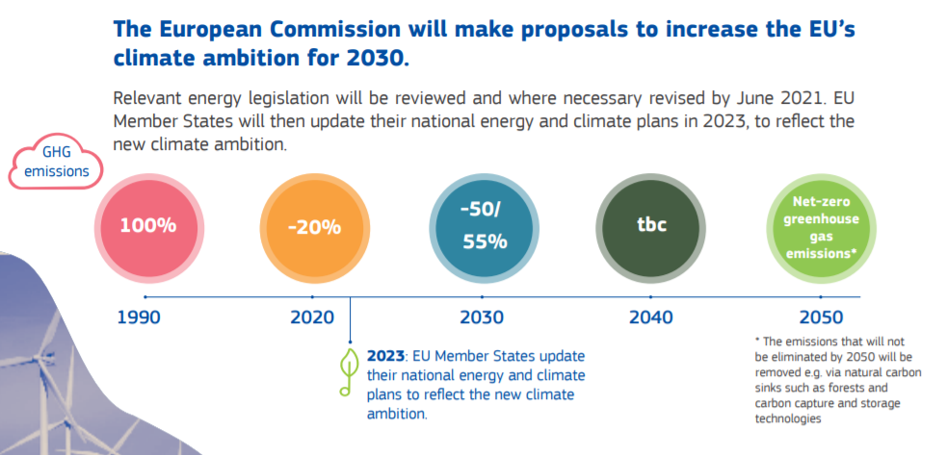

Figure 1 - Clean energy targets Green Deal72

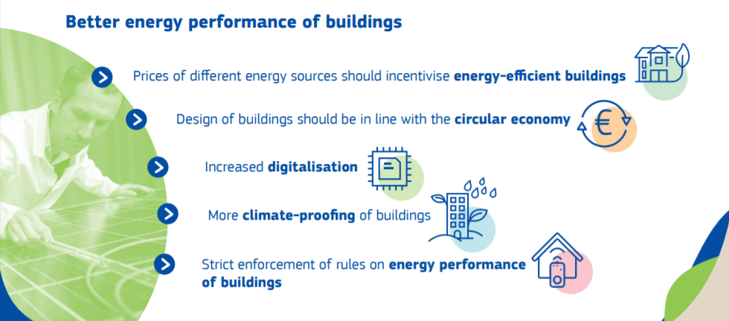

Figure 2 - Building and Renovation targets Green Deal73

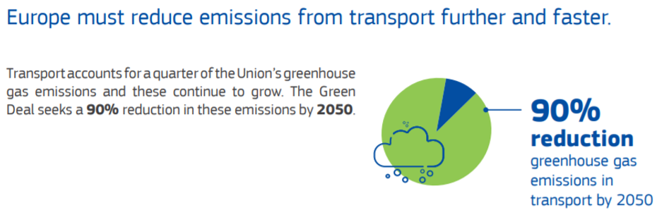

Figure 3 - Sustainable mobility targets Green deal74

The Commission stated that the European Green Deal will reflect this growth strategy in its long-term vision for rural areas. It will pay particular attention to the role of outermost regions in the European Green Deal, considering their vulnerability to climate change and natural disasters and their unique assets: biodiversity and renewable energy sources. The Commission will take forward the work on the Clean Energy for EU Islands Initiative to develop a long-term framework to accelerate the clean energy transition on all EU islands.

On the 4th of March 2020 the European Commission unveiled the **European Climate Law**75 proposal aiming at cutting greenhouse gas emissions to zero by 2050 and making it legally-binding for all member states. The European Commission is proposing a mechanism for regularly raising the EU’s emissions reduction target over the next three decades. By September 2020, the Commission shall review the Union’s 2030 target for climate in light of the climate-neutrality objective and explore options for a new 2030 target of 50 to 55% emission reductions compared to 1990. The European Commission stressed that she will engage with all parts of society to enable and empower them to take action towards a climate-neutral and climate-resilient society, including through launching a European Climate Pact.

On **30 November 2016**, the European Commission published its so-called "Winter Package" with eight proposals to facilitate the transition to a "clean energy economy" and to reform the design and functioning of the European Union's electricity market. This package of proposals can be divided into three categories:

* proposals to amend the existing energy market legislation;
* proposals to amend the existing climate change legislation;
* proposals for new measures.

In the autumn of 2018 and spring of 2019, several directives were adopted under the **Clean Energy for all Europeans Package**. The eight legislation measures can be placed in four groupings:

1. Energy Efficiency:

* The Energy Efficiency Directive; and
* The Energy Performance in Buildings Directive

1. Internal Energy Market Reform:

* The Internal Electricity Market Design Regulation;
* The Internal Electricity Market Design Directive;
* The Agency for the Cooperation of Energy Regulators (ACER) Regulation; and
* The Risk Preparedness in the Electricity Sector Regulation.

1. Renewable Energy:

* The Renewable Energy Directive;

1. Governance:

* The Governance of the Energy Union and Climate Action Regulation.

These new Electricity Market Design (EMD) rules make the energy market fit for the future and place the consumer at the centre of the clean energy transition. The new rules are designed to empower energy consumers to play an active role in driving the energy transition and to fully benefit from a less centralised, and more digitalised and sustainable energy system. The new rules enable the active participation of consumers whilst putting in place a strong framework for consumer protection.

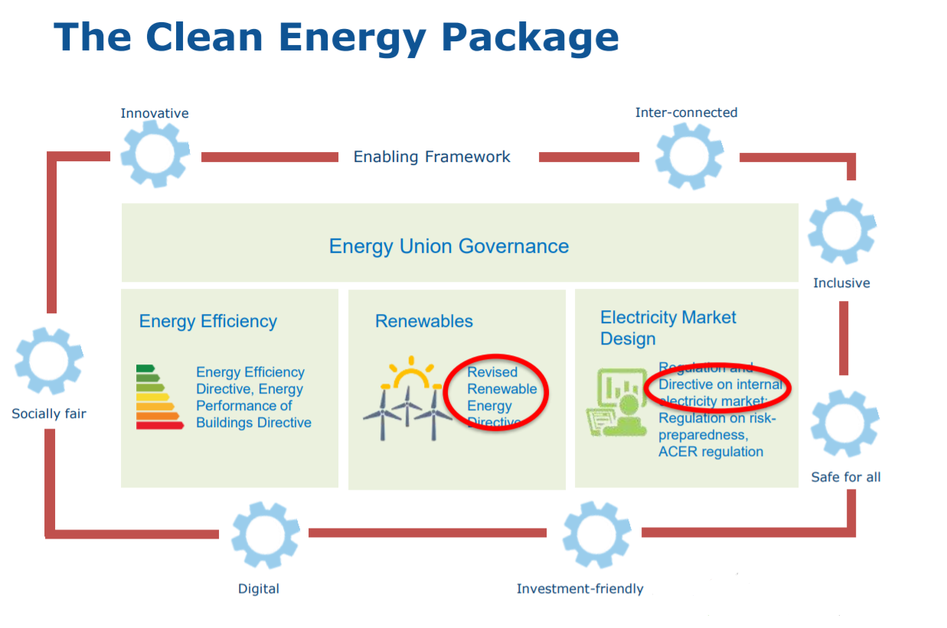

Figure 4 - Structure of the CEP76

1. Energy Communities

**For EU Islands the most important new rules** are those that empower citizens and small producers under the new concept of **Renewable (REDII) or Citizens (EMD) Energy Communities**. These are groups of citizens, social entrepreneurs, public authorities and community organisations participating directly in the energy transition by jointly investing in, producing, selling and distributing renewable energy.

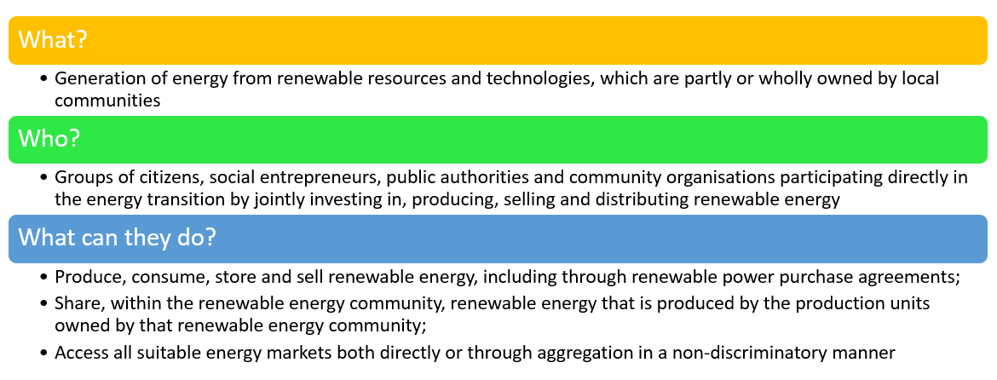

It is noticed throughout the EU that the participation of local citizens and local authorities in renewable energy projects through renewable energy communities has resulted in substantial added value in terms of local acceptance of renewable energy and access to additional private capital which results in local investment, more choice for consumers and greater participation by citizens in the energy transition. Therefore, the RED II and the EMD state that the Member States should ensure that renewable energy communities can participate in available support schemes on an equal footing with large participants. To that end, Member States should be allowed to take measures, such as providing information, providing technical and financial support, reducing administrative requirements, including community-focused bidding criteria, creating tailored bidding windows for renewable energy communities, or allowing renewable energy communities.

It is up to the Member States to set the fees and tariffs to be borne by the CEC. They can allow the CEC to be a distribution system operator (DSO) or a closed distribution system operator (CDS), and they must facilitate the roll-out of RECs by removing market barriers and taking account of RECs in support mechanisms.

### References

1. Croatia aims to triple wind, boost solar energy capacities 20 times in next 10 years. *Balk Green Energy News*. April 2019. https://balkangreenenergynews.com/croatia-aims-to-triple-wind-boost-solar-energy-capacities-20-times-in-next-10-years/. Accessed August 28, 2019.

2. Energy, transport and environment indicators — 2018 edition. https://ec.europa.eu/eurostat/web/products-statistical-books/-/KS-DK-18-001. Accessed August 29, 2019.

3. Statistics | Croatia - Total Primary Energy Supply (TPES) by source (chart). https://www.iea.org/statistics/?country=CROATIA&year=2016&category=Energy%20supply&indicator=TPESbySource&mode=chart&dataTable=BALANCES. Accessed August 28, 2019.

4. Bank TW. *Croatia Energy Sector Note*. The World Bank; 2018:1-48. http://documents.worldbank.org/curated/en/126131551124308323/Croatia-Energy-Sector-Note. Accessed August 28, 2019.

5. Croatia energy efficiency & Trends policies | Croatia profile | ODYSSEE-MURE. https://www.odyssee-mure.eu/publications/efficiency-trends-policies-profiles/croatia.html. Accessed August 29, 2019.

6. Final NECP Croatia. https://ec.europa.eu/energy/sites/ener/files/documents/hr_final_necp_main_en.pdf.

7. Energy: Something is changing in Croatia... *Indep Balk News Agency*. July 2019. https://balkaneu.com/energy-something-is-changing-in-croatia/. Accessed August 26, 2019.

8. Croatian Energy Regulatory Agency (HERA). https://www.hera.hr/en/html/index.html. Accessed August 27, 2019.

9. HROTE - Hrvatski operator tržišta energije d.o.o. https://www.hrote.hr/en. Accessed August 27, 2019.

10. HEP Group Companies. hep.hr. http://www.hep.hr/hep-group-companies-2506/2506. Accessed August 28, 2019.

11. Homepage. hep.hr. http://www.hep.hr/esco/en. Accessed August 27, 2019.

12. Fund EP and EE. Environmental Protection and Energy Efficiency Fund. Environmental Protection and Energy Efficiency Fund. http://www.fzoeu.hr/en/home/. Accessed August 27, 2019.

13. Zakon o energiji - Zakon.hr. https://www.zakon.hr/z/368/Zakon-o-energiji. Accessed March 17, 2020.

14. Expert Basis for Preparation of the Croatian Low Carbon Strategy for Period until 2030 with a Look onto 2050, White Book. May 2017. http://www.mzoip.hr/doc/bijela_knjiga.pdf.

15. Renewable Energy. Ireland 2050. http://ireland2050.ie/past/renewable-energy/. Accessed August 28, 2019.

16. Power sector leads the way decarbonising the Irish energy sector. https://www.iea.org/newsroom/news/2019/april/power-sector-leads-the-way-decarbonising-the-irish-energy-sector.html. Accessed August 28, 2019.

17. Energy Policies of IEA Countries: Ireland 2019 Review. IEA Webstore. https://webstore.iea.org/energy-policies-of-iea-countries-ireland-2019-review. Accessed August 26, 2019.

18. Ireland energy efficiency & Trends policies | Ireland profile | ODYSSEE-MURE. https://www.odyssee-mure.eu/publications/efficiency-trends-policies-profiles/ireland.html. Accessed August 29, 2019.

19. Ireland’s Transition to a Low Carbon Energy Future 2015 - 2030. https://www.dccae.gov.ie/en-ie/energy/publications/Pages/White-Paper-on-Energy-Policy.aspx. Accessed August 26, 2019.

20. Ireland draft NECP. https://ec.europa.eu/energy/sites/ener/files/documents/ireland_draftnecp.pdf.

21. Energy: Climate Action Plan 2019 – A Co-ordinated Action Plan? Mason Hayes Curran. https://www.mhc.ie/latest/insights/energy-climate-action-plan-2019-a-co-ordinated-action-plan. Accessed August 29, 2019.

22. Home - Department of Communications, Climate Action and Environment. https://www.dccae.gov.ie/en-ie/Pages/default.aspx. Accessed August 27, 2019.

23. Home. Sustainable Energy Authority Of Ireland. https://www.seai.ie/index.xml. Accessed August 27, 2019.

24. Commission for Regulation of Utilities Water and Energy - CRU Ireland. Commission for Regulation of Utilities. https://www.cru.ie/. Accessed August 27, 2019.

25. Home. http://www.eirgridgroup.com/. Accessed August 27, 2019.

26. Homepage - Electricity Supply Board. https://www.esb.ie/. Accessed August 27, 2019.

27. White Paper. https://www.dccae.gov.ie/en-ie/energy/topics/Energy-Initiatives/energy-policy-framework/white-paper/Pages/White-Paper-on-Energy-Policy-in-Ireland-.aspx. Accessed March 16, 2020.

28. Statistics | Greece - Total Primary Energy Supply (TPES) by source (chart). https://www.iea.org/statistics/?country=GREECE&year=2016&category=Energy%20supply&indicator=TPESbySource&mode=chart&dataTable=BALANCES. Accessed August 28, 2019.

29. Greece - Renewable Energy | export.gov. https://www.export.gov/article?id=Greece-Renewable-Energy. Accessed August 28, 2019.

30. Greece energy efficiency & Trends policies | Greece profile | ODYSSEE-MURE. https://www.odyssee-mure.eu/publications/efficiency-trends-policies-profiles/greece.html. Accessed August 29, 2019.

31. Energy Policies of IEA Countries - Greece Review 2017. 2017:143.

32. Final NECP Greece. https://ec.europa.eu/energy/sites/ener/files/el_final_necp_main_en.pdf.

33. ΥΠΟΥΡΓΕΙΟ ΠΕΡΙΒΑΛΛΟΝΤΟΣ ΚΑΙ ΕΝΕΡΓΕΙΑΣ. http://www.ypeka.gr/Default.aspx?tabid=37&locale=en-US&language=el-GR. Accessed August 27, 2019.

34. REGULATORY AUTHORITY FOR ENERGY. http://www.rae.gr/site/en_US/categories_new/about_rae/intro.csp. Accessed August 27, 2019.

35. Home | ΛΑΓΗΕ. http://www.lagie.gr/nc/en/home/. Accessed August 27, 2019.

36. Home | ΑΔΜΗΕ. http://www.admie.gr/nc/en/home/. Accessed August 27, 2019.

37. StartPage. HEDNO. https://www.deddie.gr/en/. Accessed August 27, 2019.

38. CRES. http://www.cres.gr/cres/index_uk.html. Accessed August 27, 2019.

39. Spain - Energy | export.gov. https://www.export.gov/article?id=Spain-energy. Accessed August 28, 2019.

40. Spain energy efficiency & Trends policies | Spain profile | ODYSSEE-MURE. https://www.odyssee-mure.eu/publications/efficiency-trends-policies-profiles/spain.html. Accessed August 29, 2019.

41. NECP Spain. https://ec.europa.eu/energy/sites/ener/files/documents/es_final_necp_main_es.pdf.

42. fernbas. National Energy and Climate Plans (NECPs). Energy - European Commission. https://ec.europa.eu/energy/en/topics/energy-strategy-and-energy-union/governance-energy-union/national-energy-climate-plans. Published January 23, 2019. Accessed August 26, 2019.

43. Ministerio para la Transición Ecológica. https://www.miteco.gob.es/es/. Accessed August 28, 2019.

44. IDAE: Quiénes somos. https://www.idae.es/en/about-us/who-we-are. Accessed August 29, 2019.

45. What is the CNMC? | CNMC. https://www.cnmc.es/en/sobre-la-cnmc/que-es-la-cnmc. Accessed August 28, 2019.

46. OMIE – Operador do Mercado Ibérico de Energia. *Europex*. January 2015. https://www.europex.org/members/omie/. Accessed August 28, 2019.

47. Home | Red Eléctrica de España. https://www.ree.es/en. Accessed August 28, 2019.

48. BOE.es - Documento BOE-A-2018-13593. https://www.boe.es/buscar/doc.php?id=BOE-A-2018-13593. Accessed March 17, 2020.

49. BOE.es - Documento BOE-A-2019-5089. https://www.boe.es/diario_boe/txt.php?id=BOE-A-2019-5089. Accessed March 17, 2020.

50. RES Italiae – Renewable Energy Sources in Italy. *Newsl Eur*. October 2018. http://www.newslettereuropean.eu/res-italiae-renewable-energy-sources-italy/. Accessed August 28, 2019.

51. • Energy mix in Italy 2017 | Statista. https://www.statista.com/statistics/873552/energy-mix-in-italy/. Accessed August 28, 2019.

52. Italy energy efficiency & Trends policies | Italy profile | ODYSSEE-MURE. https://www.odyssee-mure.eu/publications/efficiency-trends-policies-profiles/italy.html. Accessed August 29, 2019.

53. Final NECP Italy. https://ec.europa.eu/energy/sites/ener/files/documents/it_final_necp_main_en.pdf.

54. Italy Ministerial Decree of 14 July 2017. https://www.gazzettaufficiale.it/eli/id/2017/08/16/17G00136/sg.

55. Home. Mise. https://www.mise.gov.it/index.php/en. Accessed August 28, 2019.

56. Autorità per l’energia elettrica il gas ed il sistema idrico - Home page. https://www.arera.it/it/inglese/index.htm#. Accessed August 28, 2019.

57. GME - Gestore dei Mercati Energetici SpA. https://www.mercatoelettrico.org/En/Default.aspx. Accessed August 28, 2019.

58. Pagine - GSE. https://www.gse.it/en. Accessed August 28, 2019.

59. Introducing Terna - Terna spa. https://www.terna.it/en/about-us/introducing-terna. Accessed August 28, 2019.

60. E-distribuzione: fornitura e misura di energia elettrica. https://www.e-distribuzione.it/content/e-distribuzione/it/homepage.html. Accessed August 28, 2019.

61. *** NORMATTIVA ***. https://www.normattiva.it/uri-res/N2Ls?urn:nir:stato:legge:2015-12-28;221. Accessed March 16, 2020.

62. Gazzetta Ufficiale. https://www.gazzettaufficiale.it/eli/id/2020/02/29/20A01353/sg. Accessed March 16, 2020.

63. Miguel C, Mendes A, Madeira L. An Overview of the Portuguese Energy Sector and Perspectives for Power-to-Gas Implementation. *Energies*. 2018;11(12):3259. doi:10.3390/en11123259

64. Morgan S. Portugal breaks 100% renewables mark but remains isolated. *euractiv.com*. April 2018. https://www.euractiv.com/section/energy/news/portugal-breaks-100-renewables-mark-but-remains-isolated/. Accessed August 28, 2019.

65. Final NECP Portugal. https://ec.europa.eu/energy/sites/ener/files/documents/pt_final_necp_main_pt.pdf.

66. Portal ERSE - ERSE. http://www.erse.pt/eng/Paginas/ERSE.aspx. Accessed August 28, 2019.

67. REN - Homepage. https://www.ren.pt/en-GB?culture=en-GB. Accessed August 28, 2019.

68. EDP Distribuição. https://www.edpdistribuicao.pt/pt-pt. Accessed August 28, 2019.

69. EDA - Eletricidade dos Açores. https://www.eda.pt/. Accessed August 28, 2019.

70. Decreto-Lei 162/2019, 2019-10-25. Diário da República Eletrónico. https://dre.pt/home/-/dre/125692189/details/maximized. Accessed March 16, 2020.

71. Communication on The European Green Deal. European Commission - European Commission. https://ec.europa.eu/info/publications/communication-european-green-deal_en. Accessed March 16, 2020.

72. Clean energy. European Commission - European Commission. https://ec.europa.eu/commission/presscorner/detail/en/fs_19_6723. Accessed March 16, 2020.

73. Building and renovating. European Commission - European Commission. https://ec.europa.eu/commission/presscorner/detail/en/fs_19_6725. Accessed March 16, 2020.

74. Sustainable mobility. European Commission - European Commission. https://ec.europa.eu/commission/presscorner/detail/en/fs_19_6726. Accessed March 16, 2020.

75. The European Climate Law. European Commission - European Commission. https://ec.europa.eu/commission/presscorner/detail/en/FS_20_360. Accessed March 16, 2020.

76. energy_communities_in_eu_legislation_ispra_js.pdf.

1. (Articles 16 (for RECs) and 44 (for prosumers))
2. At the time of writing no final NECP has been published